Windows to The Soul

#1
Thief of Time, Unfaithful Servant, 266
Nicholas Johnson, a former commissioner of the U.S. Federal Communications Commission, once said, “All television is educational. The question is, what does it teach?”

Questions:
- How do you feel after watching TV for many hours straight?
- How does watching TV affect children?
- At what age will you let your children watch TV?
- What content will you not allow them to watch?
- What are positive and negative effects of watching TV for adults?
- Is there a connection between watching TV and alcohol abuse, violence, academic achievement, intelligence, social interaction, obesity?
- How do you feel after being on social media for many hours straight?
- What are positive and negative effects of social media?
- To what degree does advertising influence what people buy?

#2
TODAY’S LEARNING MATERIAL
Torah Bereshis
2:15 - 17
Now the Lord G-d took the man, and He placed him in the Garden of Eden to work it and to guard it.
And the Lord G-d commanded man, saying, “Of every tree of the garden you may freely eat.
But of the Tree of Knowledge of good and evil you shall not eat of it, for on the day that you eat thereof, you shall surely die.”

3:1-6
Now the serpent was cunning, more than all the beasts of the field that the Lord God had made, and it said to the woman, “Did G-d indeed say, ‘You shall not eat of any of the trees of the garden?’”
And the woman said to the serpent, “Of the fruit of the trees of the garden we may eat.
But of the fruit of the tree that is in the midst of the garden, G-d said, "You shall not eat of it, and you shall not touch it, lest you die.’”
And the serpent said to the woman, “You will surely not die.
For God knows that on the day that you eat thereof, your eyes will be opened, and you will be like angels, knowing good and evil.”
And the woman saw that the tree was good for food and that it was a delight to the eyes, and the tree was desirable to make one wise; so she took of its fruit, and she ate, and she gave also to her husband with her, and he ate.

#3
Torah Bamidbar 15:39
You shall not stray after your heart and after your eyes.
Rashi
The heart and the eyes are spies for the body. The eye sees, the heart desires, and the body commits the sin.

Kallah Rabasi, chapter 3
The body has 248 organs, and all of them are controlled by the eyes. All stumbling of man stems from the eyes.

Questions:
- Why does Rashi explain this verse in a reversed order? – Torah tells us that first you should “not stray after your heart” and only after that “after your eyes” and Rashi precedes “eyes” to “heart”!?
- How do you understand these statements?
- Can you give real life examples?

#4
Sforno
“The serpent” - he is the Satan who is the Evil Urge (Yetzer Hara). The reason why this evil urge is compared to a serpent is that just like a serpent which makes itself as invisible as possible, blending in with its environment, and yet causes more damage than the most prominently visible obstacles, so the evil urge lurks where one does not suspect to find it. … The reason why a serpent has been chosen for such a metaphor is that it is a creature whose potential harm is huge, whereas its potential benefit to man is minimal. Moreover, seeing that its visibility is minimal, it is similar to the evil urge who never attacks frontally, and often poses as friend rather than as enemy.
This means that the power of lust which brings to sin, does so through the intermediary of the power of imagination. The latter sends to him imaginations of physical pleasures which sway him away from the proper path set by G-d.
For when the power of lust joins together with the imaginations of physical pleasures, they command the physical powers to act and sin against G-d. Then when the power of intellect does not rise up and protest, the person goes and commits the sin. This is as our sages said: "the heart and the eyes are the two solicitors of sin" (Talmud Yerushalmi Berachos 1:8). On this the torah warns: “you shall not go after your hearts and after your eyes …” (Torah Bamidbar 15:39).

#5
Talmud Sotah 2a
The laws concerning the Nazir [a person who vows not to drink wine] are written immediately following the laws concerning the Sotah [the unfaithful wife]. The Rabbis comment that the purpose of the juxtaposition of these two Torah portions is to teach us that anyone who sees the disgrace (the unnatural death) of a Sotah should (immediately) take a vow to abstain from wine.

Question: Isn't it counterintuitive?
The sin of the unfaithful wife was committed at least partially due to light-headedness, absence of deliberation, and a disregard for truth and consequences. Drinking wine leads to many of the same effects. Wouldn’t someone who observed the extreme punishment of this behavior automatically learn the lesson and be careful of excessive wine consumption? Wouldn't he be scared to commit adultery?

#6
Windows to the soul: children and adults see the eyes as the location of the self
Starmans & Bloom, 2012, Yale University
Where are we? In three experiments, we explore preschoolers' and adults' intuitions about the location of the self using a novel method that asks when an object is closest to a person. Children and adults judge objects near a person's eyes to be closer to her than objects near other parts of her body. This holds even when considering an alien character whose eyes are located on its chest. Objects located near the eyes but out of sight are also judged to be close, suggesting that participants are not using what a person can see as a proxy for what is close to her. These findings suggest that children and adults intuitively think of the self as occupying a precise location within the body, at or near the eyes.

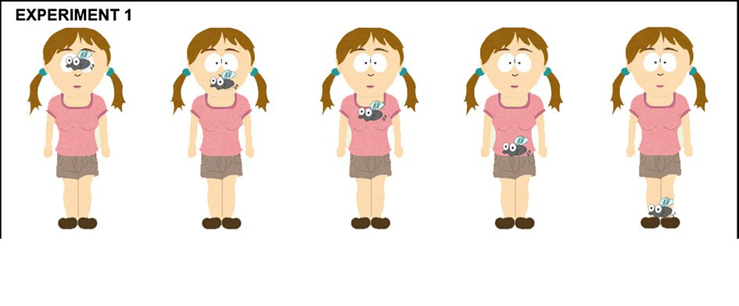
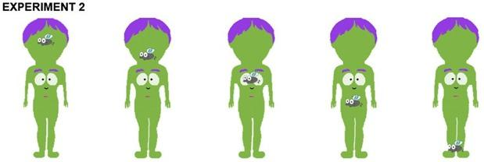

#7
Question: What’s your takeaway from today’s discussion?

